Junior Cert Mandatory Experiments
Please remember to photocopy 4 pages onto one sheet by going A3→A4 and using back to back on the photocopier

The best way to revise this section is to test yourself on your ability to draw a diagram for each experiment, then state what the result should be in each case.

Biology: pages 2 - 4
OB3 | Qualitative food tests for starch, reducing sugar, protein and fat.
OB5 | Investigate the conversion of chemical energy in food to heat energy.
OB8 | Investigate the action of amylase on starch; identify the substrate, product and enzyme.
OB11 | Carry out qualitative tests to compare the carbon dioxide levels of inhaled and exhaled air.
OB39 | Investigate the variety of living things by direct observation of animals and plants in their environment; classify living organisms as plants or animals, and animals as vertebrates or invertebrates.
OB44 | Prepare a slide from plant tissue and sketch the cells under magnification.
OB49 | Show that starch is produced by a photo-synthesising plant.
OB58 | Investigate the conditions necessary for germination
OB59 | Study a local habitat, using appropriate instruments and simple keys to show the variety and distribution of named organisms.
OB65 | Investigate the presence of micro-organisms in air and soil.

Chemistry: Pages 5 - 8
OC2 | Separate mixtures using a variety of techniques: filtration, evaporation, distillation and paper chromatography.
OC17 | Grow crystals using alum or copper sulphate.
OC19 | Investigate the pH of a variety of materials using the pH scale
OC22 | Show that approximately one fifth of the air is oxygen;  Show that there is CO₂ and water vapour in air.
OC24 | Prepare a sample of oxygen by decomposing H₂O₂ using MnO₂ as a catalyst.
OC27 | Prepare carbon dioxide and show that it does not support combustion.
OC30 | Conduct a qualitative experiment to detect the presence of dissolved solids in water samples, and test water for hardness (soap test).
OC38 | Titrate HCl against NaOH, and prepare a sample of NaCl.
OC46 | Carry out an experiment to demonstrate that oxygen and water are necessary for rusting.
OC51 | Investigate the reaction between zinc and HCl, and test for hydrogen.

Physics: 9 - 13
OP2 | Measure the mass and volume of a variety of solids and liquids and hence determine their densities.
OP6 | Investigate the relationship between the extension of a spring and the applied force.
OP20 | Identify different forms of energy and carry out simple experiments to show the following energy conversions:  (a) chemical to electrical to heat energy (b) electrical to magnetic to kinetic energy  (c) light to electric to kinetic energy.
OP23 | Investigate and describe the expansion of solids, liquids and gases when heated, and contraction when cooled.
OP31 | Carry out simple experiments to show the transfer of heat energy by conduction, convection and radiation; investigate conduction and convection in water.
OP34 | Show that light travels in straight lines.
OP38 | Investigate the reflection of light by plane mirrors, and illustrate this using ray diagrams;  demonstrate and explain the operation of a simple periscope.
OP46 | Plot the magnetic field of a bar magnet.
OP49 | Test electrical conduction in a variety of materials, and classify each material as a conductor or insulator.
OP50 | Set up a simple electric circuit; use appropriate instruments to measure current, potential difference (voltage) and resistance, and establish the relationship between them.
Biology Experiments
OB3 | Qualitative food tests for starch, reducing sugar, protein and fat.

Food Tested | Procedure / Chemicals Used | Positive Result
Starch | Add iodine | Turns blue-black
Reducing sugar e.g. glucose | Add Benedict’s solution and heat | Turns brick-red
Fat | Rub food on brown paper | Translucent Stain
Protein | Add sodium hydroxide and then copper sulfate | Turns purple

OB5 | Investigate the conversion of chemical energy in food to heat energy.

Procedure
- Pour water into a test-tube and note the temperature.
- Place a burning cream-cracker or peanut under the test-tube.
- Leave for a minute.
- Take the temperature of the water again.
Result
The temperature of the water rises as a result of gaining energy from the burning peanut.

OB8 | Investigate the action of amylase on starch; identify the substrate, product and enzyme.

Procedure:
- Add some saliva (which contains the amylase enzyme) to a starch solution which is in a test tube.
- Confirm beforehand that the substrate is starch by adding iodine to it – it should turn blue/black.
- Heat in a water bath at 37 ⁰C for 10 minutes.
- The starch should now be converted to a simple sugar product called maltose so we need to test for this.
Add some Benedict’s solution and place in boiling water for a few minutes.
Result
The contents of the test-tube should turn red, indicating that sugar is present.

OB11 | Carry out qualitative tests to compare the carbon dioxide levels of inhaled and exhaled air.
Procedure
- Suck air in through position A in Test tube A.
Result: it takes a long time for the limewater to go milky.
- Replace the limewater and this time exhale air through the top of the tube as shown in Test tube B
Result: the limewater goes milky quickly.
Conclusion
There is more carbon dioxide in exhaled air.

OB39 | Investigate the variety of living things by direct observation of animals and plants in their environment; classify living organisms as plants or animals, and animals as vertebrates or invertebrates.

Procedure
- Pick a habitat (e.g. a hedge) and identify as many plants and animals as you can.
- Record your results in a table – have separate columns for plants, vertebrate animals and invertebrate animals.

OB44 | Prepare a slide from plant tissue and sketch the cells under magnification.

Procedure
- Place a drop of iodine onto a clean glass slide (iodine is used to ‘stain’ a cell and make it easier to see).
- Cut an onion and remove a thin layer of inner cells (called the ‘tissue’).
- Place it on the slide and place a cover slip on top.
- Place the glass slide on the stage and secure with clips.
- Watch from the side and turn the coarse focus wheel so that the objective lens is as close to the stage as possible.
- Put your eye to the eyepiece and gently turn the fine focus wheel the opposite way to sharpen the image.

OB49 | Show that starch is produced by a photo-synthesising plant.

Procedure
- Place a plant in the dark for a few days so that all the starch is removed.
- Place aluminium foil over one of the leaves and put the plant in strong sunlight for a day.
- Put the leaves in boiling water for a minute to kill and soften them.
- Soak the leaves in alcohol for a few minutes to remove the chlorophyll (this also makes them brittle).
- Dip the leaves in boiling water again rinse and soften them.
- Test for starch by putting drops of iodine on the leaves.
Result
The leaves will go blue-black indicating that starch is present, with the exception of the leaf which was covered with aluminium foil. There is no starch in this leaf because photosynthesis couldn’t occur since there was no sunlight.

OB58 | Investigate the conditions necessary for germination

Procedure
- Place cress seeds and cotton wool in each test-tube.
- Leave test tube A as it is [without water].
- Add a little water to test tube B [this one now has moisture, oxygen and heat].
- Keep test tube C (containing moist cotton wool) in the fridge [there is no heat].
- Add water which has cooled after boiling to test tube D and cover it with oil [no oxygen].
Result
Only the test tube containing the moist cotton wool at room temperature germinated.
Conclusion
Moisture, oxygen and heat are necessary for germination

OB59 | Study a local habitat, using appropriate instruments and simple keys to show the variety and distribution of named organisms.

Equipment
- Pooter, pitfall trap, sweep net, beating tray (these are all used to collect animals).
- Quadrat (used to estimate the distribution of plants in the habitat).
Procedure
- Record all animals found in a table.
- Use the results obtained from using the quadrat to draw up a second table and estimate the percentage frequency of each plant in the habitat.

OB65 | Investigate the presence of micro-organisms in air and soil.

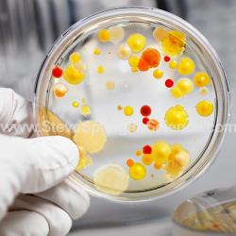
Equipment: Petri dishes containing a layer of sterile (uncontaminated) nutrient called agar (the agar acts as a food source).
Procedure
- Add some soil to one of the petri dishes and leave another sterile as a control.
- Leave both for a few days in a warm environment.
Result:
After a few days bacteria colonies can be seen in the petri dish which had soil but not in the sterile dish.
Shiny dots correspond to bacterial colonies while fluffy growth corresponds to fungi.

Chemistry Experiments

OC2 | Separate mixtures using a variety of techniques: filtration, evaporation, distillation and paper chromatography.
Filtration
Equipment
A solution of soil and water, filter paper, filter funnel, conical flask and beaker.
Procedure:
Carefully pour the solution into the conical flask – the water will flow through, leaving just the soil behind.
Note that the disadvantage with this method is that you don’t get to keep the liquid – see the distillation experiment for a solution to this.

Evaporation
Equipment:
Evaporating dish, salt solution
Procedure:
Simply heat the water and salt solution – the water will evaporate, leaving just the salt behind.
The problem with simple evaporation is that you lose the liquid.

Distillation

A: Thermometer
B: Water out to sink
C: Condenser
D: Cold water in
E: Tripod stand
F: Bunsen burner

Procedure
- Set up as shown.
- Part C is called a condenser; it has an outer tube which carries cold water – this causes the water vapour passing through the inner tube to condense back into water.
- Cold tap-water goes in through D and out through B.
- The round-bottom flask above the Bunsen burner contains sea-water.
Result
The water evaporates from the round-bottom flask, travels through the condenser where it condenses and flows into flask B as pure water.

Chromatography
Procedure
- Put an ink spot just above the water line as shown.
Result
Water rises up through the chromatography paper and takes the various colours which were in the ink spot to different heights.

OC17 | Grow crystals using alum or copper sulphate.
Procedure:
- Keep adding copper to hot water until no more will dissolve
- Filter the mixture (see the filtration experiment) and pour the liquid (called the filtrate) into an evaporating dish.
- Allow to cool slowly.
Result:
Crystals begin to grow

OC19 | Investigate the pH of a variety of materials using the pH scale

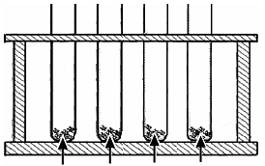
Apparatus:
Rack of test tubes, everyday acids and bases.
Acidic: citric acid (e.g. lemon juice, orange juice) apples, sour milk, vinegar, fizzy drinks and tea.
Basic: tooth paste, lime water, bread soda, toothpaste, window cleaner and caustic soda.
Procedure:
- Put substances in test tubes (they must be dissolved in water if they are not a liquid).
- Pour in a few drops of universal indicator and shake well (the colour will change according to how acidic or basic the substance is).
- Use the pH scale to write up results.

OC22 | Show that approximately one fifth of the air is oxygen;  Show that there is CO₂ and water vapour in air.

To show that approximately one fifth of the air is oxygen

Method one
- Set up as shown
- Light the candle, place it gently on the surface of the water and then carefully lower the graduated cylinder into the water over the candle.
Result
The water rises approximately one fifth of the height of the graduated cylinder to replace the oxygen used up by the burning candle.
Method two
- Set up as shown - use a Bunsen burner as the heat source.
- Note the total volume of air in both syringes.
- Gently push the air over and back in the syringes until all the copper powder has become oxidised.
Result
Volume of air before heating = 100cm³
Volume of air after heating the copper = 79cm³
Volume of oxygen present in 100cm³ = 21 cm³
Percentage of air = 21/100 = 21%

To show that there is carbon dioxide in air
Procedure: Use a ball pump or bicycle pump to pump air through a beaker of limewater.
Result: After a minute or two the limewater turns milky proving that there is carbon dioxide in air.

To show that there is water vapour in air
Procedure:
- Fill a test-tube with ice and water and leave it for a few minutes; a liquid will form on the outside of the test-tube.
- Test the liquid using blue cobalt-chloride paper.
Result: The blue cobalt-chloride paper turns pink showing that the liquid which condensed was water.
OC24 | Prepare a sample of oxygen by decomposing H₂O₂ using MnO₂ as a catalyst.
Hydrogen peroxide → oxygen + water
H₂O₂ → O₂ + H₂O

Manganese dioxide (MnO₂) is added in as a catalyst (to speed up the reaction)

Procedure
- Set up as shown (X in the diagram is hydrogen peroxide and Y is manganese dioxide).
- Slowly release the hydrogen peroxide into the flask underneath.
Result
Oxygen bubbles through the water in the trough.
Test for oxygen – it relights a glowing splint.

OC27 | Prepare carbon dioxide and show that it does not support combustion.
Procedure
- Set up as shown (calcium carbonate is the chemical name for marble chips).
- Slowly release the hydrochloric acid into the flask underneath.
Result
Carbon dioxide is collected it the gas jar.
To test for carbon dioxide pour a small volume of limewater into the jar and shake it – the limewater will turn milky showing that the gas is carbon dioxide.

To show that carbon dioxide does not support combustion
Light a wooden splint and insert it into a gas jar of carbon dioxide.
Result
The splint will extinguish showing that carbon dioxide does not support combustion.

OC30 | Conduct a qualitative experiment to detect the presence of dissolved solids in water samples, and test water for hardness (soap test).

To detect the presence of dissolved solids in water samples
Pour tap water into a clean beaker and then boil the water off using a hotplate.
The dissolved solids will remain on the sides of the glass and on the bottom of the beaker.

To test water for hardness
Hard water requires a lot of soap to form a lather, so to check for hard water simply add soap and see if it forms a lather.

OC38 | Titrate HCl against NaOH, and prepare a sample of NaCl.

Apparatus:
A is a burette, B is a pipette, conical flask, retorts stand, , hotplate, white tile, evaporating dish, dropper, beakers.
Chemicals: dilute hydrochloric acid, dilute sodium hydroxide, methyl orange indicator.

Method:
- Set up apparatus as shown in diagram.
- Using the pipette for accurate measurement, put 25cm³ of dilute sodium hydroxide into the conical flask.
- Fill the burette above the 0 mark with dilute hydrochloric acid.
- Fill the part of the burette below the tap by letting some of the acid pour out (into an empty beaker) until the level of the liquid is at the 0 mark.
- Add around 3 drops of the indicator to the base in the conical flask.
- Place the flask on a white tile under the burette.
- Slowly add the acid into the conical flask until the liquid in the conical flask remains pink.
- The new reading on the burette is the amount of acid required to neutralise the base.

- Pour the contents in the conical flask into the evaporating dish and evaporate it to almost dryness.
- Let solution cool - white crystals of NaCl will form in the dish.
Note
You could use a variety of pH indicators instead of methyl orange; the neutralisation colour might change accordingly. Alternatively you could use pH indicator strips or a digital pH meter.

OC46 | Carry out an experiment to demonstrate that oxygen and water are necessary for rusting.

Procedure
- Get three separate test tubes.
- In the first test tube put in water and nails.
- In the second test tube put in water and then boil it to remove any dissolved oxygen.
Then put in the nails and pour in some oil on top to prevent further oxygen entering.
- In the third test tube put in nails with some calcium chloride to absorb any moisture and cover to prevent further water entering.
- Leave for a week.
Result
Only the nails in test-tube A will rust, demonstrating that both air and water are necessary for rusting.

OC51 | Investigate the reaction between zinc and HCl, and test for hydrogen.
zinc + hydrochloric acid → zinc chloride + hydrogen

- Drop some zinc metal into a test-tube containing hydrochloric acid and collect the gas given off in a gas jar.
- Test the gas; it burns with a ‘pop’ showing that the gas is hydrogen.
Physics Experiments

OP2 | Measure the mass and volume of a variety of solids and liquids and hence determine their densities.
Measure mass and volume of a variety of solids and liquids and hence determine their densities.
- To measure the density of a regularly-shaped block
- To measure the density of an irregularly-shaped small stone
- To measure the density of an irregularly-shaped large stone
- To measure the density of a liquid

Summary of all the experiments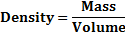
In each case to calculate the density we simply use the formula:

To measure the density of a regularly-shaped block
To find the mass - weigh it on an electronic balance.

To find the volume:
Volume = length × width × height
In this case the volume is 5 × 2 × 1 = 10 cm³.

To measure the density of an irregularly-shaped small stone
To find the mass - weigh it on an electronic balance.

To find the volume:
Drop the stone into a graduated cylinder containing water and note the new volume.
To get the volume of the stone simply subtract the two readings.
In this case the volume = 90 – 75 = 15 cm³.

To measure the density of an irregularly-shaped large stone
To find the mass - weigh it on an electronic balance.

To find the volume:
Fill an overflow can up to the top and place an empty graduated cylinder under the spout.
Carefully drop the stone in (using a string so there is no splash).
Note the level of water in the overflow can.

To measure the density of a liquid
To find the mass:
Weigh an empty graduated cylinder, and then weigh the graduated cylinder after pouring water into it.
Then subtract the two readings.

To find the volume simply note the level of water in the graduated cylinder.

OP6 | Investigate the relationship between the extension of a spring and the applied force.

Procedure
- Use a newton-meter to stretch a spring (or hand weights from the spring as shown).
- Note the extension and the force used and record the results in a table.
- Repeat for lot of different forces.
- Plot a graph of force used against extension.
Result: You should get the graph on a straight line.

Conclusion: The graph is a straight line through the origin which shows that the extension is directly proportional to the applied force.

This may well be the first time that you have come across the phrase ‘directly proportional’ – it means that the force and the extension change at the same rate; if the force on the string doubles so will the extension; if the force triples then the extension will triple also etc.

You must remember this term because it often gets asked in exams (even if it doesn’t appear in textbooks).

OP20 | Identify different forms of energy and carry out simple experiments to show the following energy conversions:  (a) chemical to electrical to heat energy  (b) electrical to magnetic to kinetic energy  (c) light to electric to kinetic energy.
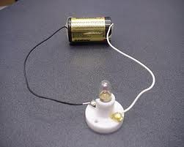
- Chemical energy to electrical energy to heat energy
An electric circuit consisting of a battery connected to a light-bulb or heater.
Switch on the circuit and note the temperature rising using a thermometer.

- Electrical energy to magnetic energy to kinetic energy
Use an electromagnet (a coil of wire wrapped around a nail, connected to a battery) to pick up some nails.
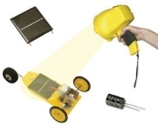

- Light energy to electrical energy to kinetic energy
Connect a solar panel to an electric motor which turns the wheels in a car when light shines on the solar panel.

OP23 | Investigate and describe the expansion of solids, liquids and gases when heated, and contraction when cooled.
Solids expand when heated and contract when cooled
Procedure
Heat the brass ball.
Result: the ball fits through the ring when the ball is cold but doesn’t fit through when it is hot.
Liquids expand when heated and contract when cooled
Procedure
- Connect a glass tube to the top of a beaker of water (use dye to make the water more visible).
- Use a Bunsen burner or hair-dryer to heat the beaker of water.
Result: the water rises up the tube as it gets heated and drops back down as it cools.

Gases expand when heated and contract when cooled
Procedure
- Gently heat the flask of air (much better to use a hair dryer in case the flask breaks).
Result: that bubbles come out of the tube when the flask is heated and as it cools water from the trough rises back up the tube because of the partial vacuum which has formed.

OP31 | Carry out simple experiments to show the transfer of heat energy by conduction, convection and radiation; investigate conduction and convection in water.
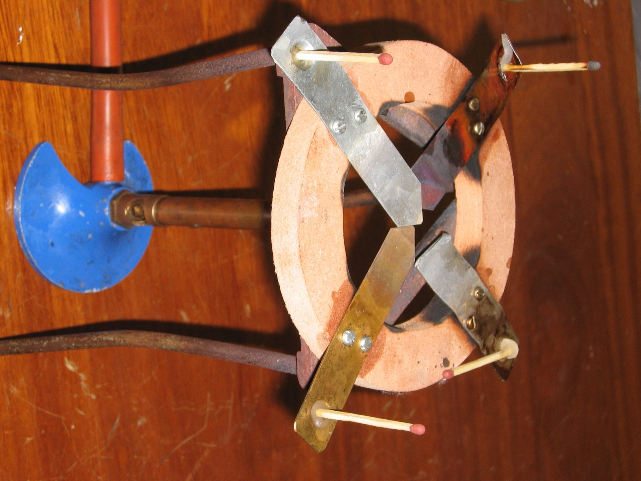
Conduction
To compare the ability of different metals to conduct heat
Procedure
- Use the apparatus shown which consists of a piece of timber with four different strips of metal.
- Place some candle wax at the end of each metal and stand a match in the wax at the end.
- Light the Bunsen (or candle) under the middle and note the order in which the matches fall.
Result: the match which falls first was standing in the best conductor.

To show that water is a poor conductor of heat
Procedure
- Half fill a boiling tube with water and use piece of metal gauze to hold down the ice.
- Holding the boiling tube at an angle with a tongs, heat it at the top using the Bunsen burner for a short period of time.
Result: the water at the top boils while the ice at the bottom stays frozen.

Convection
To demonstrate convection currents in water
- Use the apparatus shown and drop in some copper sulphate or potassium permanganate to act as a dye.
- Place the Bunsen under one of the corners and note the movement of the water around the apparatus.
Result: the water over the Bunsen will rise and set in motion a convection current which travels around the tube.
To demonstrate convection currents in air
radiator
Procedure
- Cut tissue paper into narrow strips;
- Tie the strips together at one end using the piece of thread and hang them from a retort stand as shown over a hot-plate.
Result: the tissue paper will begin to move as a result of the convection current generated by the hot-plate.

Radiation
Dark materials are better radiators of heat than shiny materials.
Demonstration
- Take two identical metal containers and paint one with one black and the other silver.
- Fill both with hot water.
- Using a thermometer and stop-watch note which container cools the quickest.
Result: The dark container cooled more quickly because it is a better radiator of heat.

OP34 | Show that light travels in straight lines.
Procedure
- Set up as shown.
- Line up the three cards (with a hole in the middle of each) in a straight line using a piece of cord to keep them straight.
Result: you can only see light from the lamp when the holes in the card are lined up.

OP38 | Investigate the reflection of light by plane mirrors, and illustrate this using ray diagrams;  demonstrate and explain the operation of a simple periscope.

Procedure
Use a ray box to shine a ray of light off a mirror.
Result: the light ray comes back out (reflects) at the same angle as it goes in.
Complete the diagram on the right.

How a periscope works
Procedure
Set up as shown.
Result: Some of the light coming from the card hits the first mirror, then gets reflected from this onto the second mirror where it gets reflected again and travels out to the eye of the observer.

OP46 | Plot the magnetic field of a bar magnet.
Equipment: Magnet, sheet of paper, compasses
Procedure:
- Place the plotting compass beside the magnet and mark the position of the north end.
- Move the position of the compass and repeat a number of times on both sides of the magnet.
- Join the dots.
Result: a pattern is formed on the paper representing the magnetic field of the magnet.

OP49 | Test electrical conduction in a variety of materials, and classify each material as a conductor or insulator.

Procedure
- Set up the circuit as shown.
Label | Circuit component
A | Switch
B | Power supply
C | Resistor
D | Bulb

- Place various different materials between points X and Y in the circuit and turn on the switch.
- If the bulb lights then the material is a conductor and if it doesn’t then the material is an insulator.
- Record the result in a table.

OP50 | Set up a simple electric circuit; use appropriate instruments to measure current, potential difference (voltage) and resistance, and establish the relationship between them.

Procedure
- Set up the circuit as shown.
- Note the current (I) and potential difference (V).
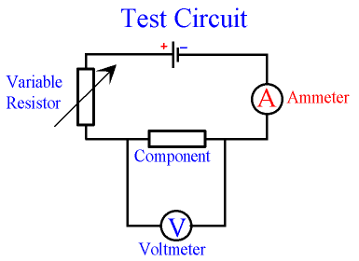
- Adjust the variable resistor (rheostat) to get a new set of values.
- Repeat about 6 times and then plot a graph of potential difference against current.
- Record the results in a table and then draw a graph of potential difference against current.
Result
The fact that we get a straight line through the origin shows that the potential difference is directly proportional to the current (this means that if we double the potential difference, the current will double also).

Note that the slope of the graph corresponds to the resistance of the component.

